Instruction

[english translation by MS]

In this experiment you will be shown moving circles You can move a green circle with the mouse inside of a large circular area. Your task is to avoid contact with the white circles by staying away from them.

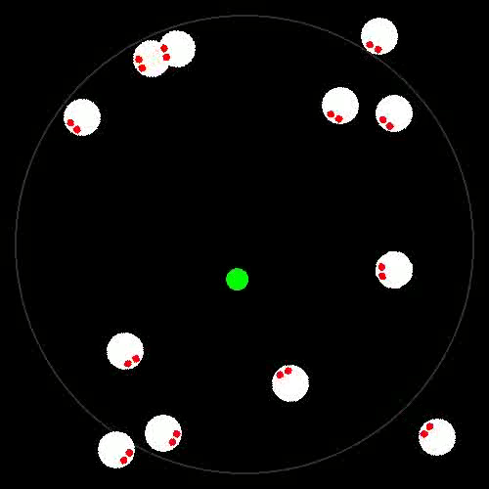

You initiate each trial by clicking on the green circle with the mouse. You can use this phase to bring the mouse into comfortable position on the table. Each trial lasts 17 seconds. At the end of each trial all but one of the circles remain frozen at their last position. One white circle disappears. You task is to select the last position of the missing circle with mouse. You should fully concentrate on the first task – to avoid contact with white circles. As a consequence you may sometimes fully miss where the white circle disappeared. In this case, please, do not guess, but click on the green circle instead. After you have selected the position experiment will resume with next trial.

The experiment consists of three blocks. Each block takes 15-20 minutes.

